New Payment/Notification Portal Sign Up Instructions
If you received an email with the link, click on the link. If not, go to our website: rwrwa.org and hit the ‘Bill Payment’ button, then select the appropriate button based off your location, and you will be redirected to the website. Or scan the above QR code with your cell phone camera.
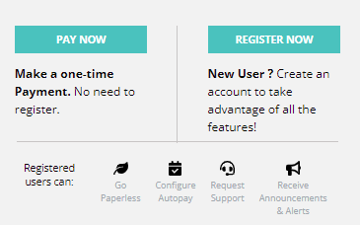
Your options are to make a One-time payment or Register - select ‘Register Now’ to access your account. Type in your name & account # and follow the steps to create a secure account. Type in the PIN that you were emailed with the link. If you did not receive an email, you can change the options to instead enter your last name or billing street name. Create a login & password. Enter your email address. We also recommend entering your mobile phone number; however, it is not required. You will receive an email to activate your account. Make sure to go to your email and click on the button/link to fully activate your account. Once activated, log in to your account.

Linking multiple accounts:
Select the ‘Account Name’ menu, located on the far right of the screen. Select ‘Add another account’. Add the account number. Enter the PIN you received in an email, OR enter your last name, OR billing street name.
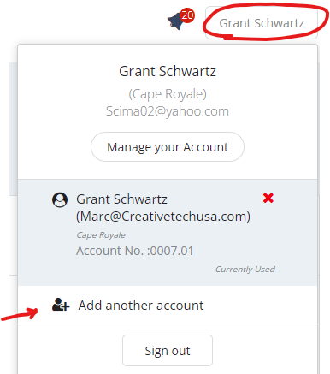

Signing up for autopay:
On the dashboard, click ‘Change’ next to AutoPay. Then click ‘Select Payment Method’. Add a payment source by selecting ‘new card’ OR ‘new bank account’. Enter your information. Make sure the circle next to your payment source is selected, then click ‘Save.’ Next, turn Auto Pay ON by putting a check mark in the “Auto Pay ON” check box. THIS MUST BE DONE IN ORDER TO ACTIVATE AUTO PAY AND CLICK THE SAVE button. Click OK to confirm that Autopay is now activated.
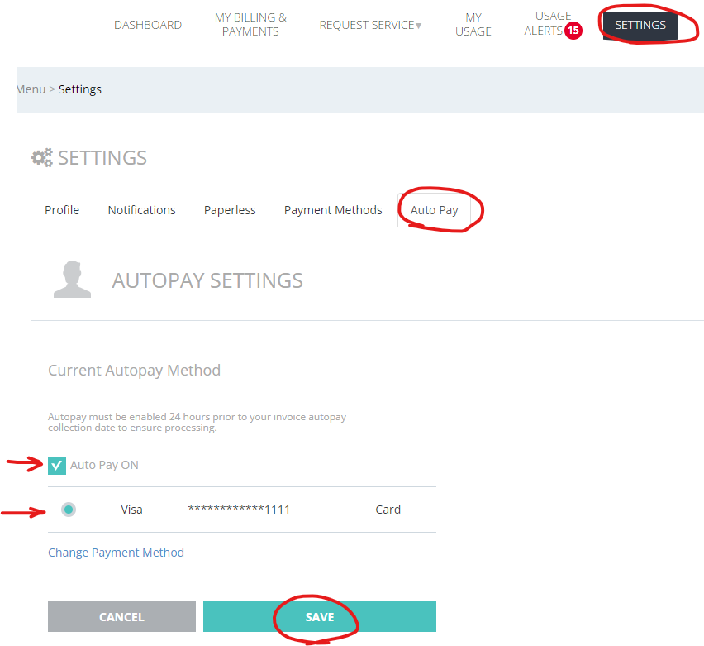
Note: Please sign up for auto pay 24 hours in advance. Autopay is scheduled to be drafted on the due date listed on your bill. The total balance due is the amount that will be withdrawn; partial payments cannot be done on autopay.
One Time/Custom Payments:
On the dashboard, select ‘Payment Options’ then click on the ‘Pay Now’ button. Select ‘new card’ OR ‘new bank account’ and then fill in your information. Acknowledge the enrollment clause, then click ‘Continue’. Select your payment source and click ‘Pay Now’. Only click the PAY NOW button ONCE. Click ‘OK’ to confirm payment.
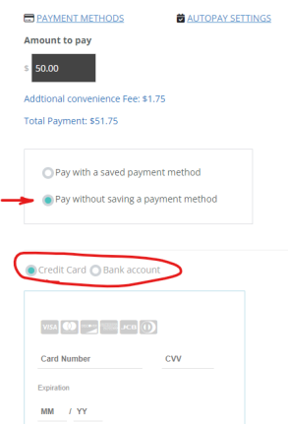
Signing up for emergency alerts:
On the dashboard, click on ‘Settings’, then select the ‘Notifications’ tab. Here, you can choose whether you want alerts emailed or texted to you or both.
